|  |  |  |  |  |
| --- | --- | --- | --- | --- |
| Fecha | Versión | Incidencias | Entrega | Comentario |
| 24/11/2022 | Inicial | 8 |  | No se ha podido probar la funcionalidad al no mostrarse los registros en la tabla. |
| 02/12/2022 |  | 5 |  |  |
| 13/12/2022 | v.2 | 4 | 13/12/2022 13:04 | No se habilita el botón de Descartar. Error al no incluir el comentario en la entrega. |

**PANTALLA EJECUTAR**

1. Tenemos dos scripts para ejecutar sin histórico. Seleccionamos solo el primero y lo ejecutamos sin error. Si seleccionamos el script no se está habilitando el botón de Descartar y no se puede probar dicha funcionalidad. En el documento se indica lo siguiente:

*Si hay scripts de histórico ejecutados correctamente (aunque solo sea uno), el botón de* ***Descartar*** *estará siempre deshabilitado.*

*En caso contrario:*

* *Si se selecciona un script con estado* ***Ejecutado*** *en la tabla de vigente, se habilitará el botón* ***Descartar****. En caso contrario, el botón permanecerá deshabilitado.*
* *Si se pulsa el botón* ***Descartar****, se mostrará la pantalla (modal) Descartar Script (ver punto Pantalla Descartar Script).*

1. Volvemos a procesar un script que genera dos ficheros. Ejecutamos el primero sin errores. Actualiza sus datos en el listado. Ejecutamos el segundo sin errores y nos redirige a la pantalla de resumen. Pulsamos entregar y se produce un error:

12:22:16.701 [AWT-EventQueue-0] INFO c.m.u.l.PantallaResumenProcesadoActionListener - Zip file name: \\Nes011901-007\modelodatos\TEMPORAL_PUESTOS_VIRTUALES\MARIPAM\MDSQL_JAVA\pruebas\MDSQL_IGR\20221124_12_18_MDSQL_IGR_DD_SDFFFFF.zip

12:22:16.785 [AWT-EventQueue-0] INFO c.m.u.l.PantallaResumenProcesadoActionListener - Ruta entregados: C:\MDSQL_JAVA\scripts\creacionTablasSMD_LD\Entregable

12:22:16.790 [AWT-EventQueue-0] ERROR c.m.u.l.PantallaResumenProcesadoActionListener - \\Nes011901-007\modelodatos\TEMPORAL_PUESTOS_VIRTUALES\MARIPAM\MDSQL_JAVA\pruebas\MDSQL_IGR\20221124_12_18_MDSQL_IGR_DD_SDFFFFF.zip -> C:\MDSQL_JAVA\scripts\creacionTablasSMD_LD\Entregable\20221124_12_18_MDSQL_IGR_DD_SDFFFFF.zip

12:22:16.790 [AWT-EventQueue-0] ERROR c.m.u.l.PantallaResumenProcesadoActionListener - C:\MDSQL_JAVA\scripts\creacionTablasSMD_LD\20221124_12_18_MDSQL_IGR_DD_SDFFFFF.sql -> C:\MDSQL_JAVA\scripts\creacionTablasSMD_LD\Entregable\20221124_12_18_MDSQL_IGR_DD_SDFFFFF.sql

12:22:16.791 [AWT-EventQueue-0] ERROR c.m.u.l.PantallaResumenProcesadoActionListener - C:\MDSQL_JAVA\scripts\creacionTablasSMD_LD\20221124_12_18_MDSQL_IGR_DC_SDFFFFF.pdc -> C:\MDSQL_JAVA\scripts\creacionTablasSMD_LD\Entregable\20221124_12_18_MDSQL_IGR_DC_SDFFFFF.pdc

12:22:16.792 [AWT-EventQueue-0] INFO c.m.b.service.impl.ServiceSupport - {call SM2_K_LD_MDSQL_MARIPAM.P_ENTREGAR_PETICION(?,?,?,?,?,?)}

12:22:16.794 [AWT-EventQueue-0] INFO c.m.b.service.impl.ServiceSupport - Parßmetros de entrada:

394

MARIPAM

NULL

Exception in thread "AWT-EventQueue-0" java.security.PrivilegedActionException: java.security.PrivilegedActionException: com.mdval.exceptions.ServiceException

at java.security.AccessController.doPrivileged(Native Method)

at java.security.ProtectionDomain$JavaSecurityAccessImpl.doIntersectionPrivilege(Unknown Source)

at java.awt.EventQueue.dispatchEvent(Unknown Source)

at java.awt.EventDispatchThread.pumpOneEventForFilters(Unknown Source)

at java.awt.EventDispatchThread.pumpEventsForFilter(Unknown Source)

at java.awt.EventDispatchThread.pumpEventsForFilter(Unknown Source)

at java.awt.WaitDispatchSupport$2.run(Unknown Source)

at java.awt.WaitDispatchSupport$4.run(Unknown Source)

at java.awt.WaitDispatchSupport$4.run(Unknown Source)

at java.security.AccessController.doPrivileged(Native Method)

at java.awt.WaitDispatchSupport.enter(Unknown Source)

at java.awt.Dialog.show(Unknown Source)

at java.awt.Component.show(Unknown Source)

at java.awt.Component.setVisible(Unknown Source)

at java.awt.Window.setVisible(Unknown Source)

at java.awt.Dialog.setVisible(Unknown Source)

at com.mdval.ui.utils.UIHelper.show(UIHelper.java:63)

at com.mdsql.ui.listener.FramePrincipalActionListener.evtEjecutar(FramePrincipalActionListener.java:379)

at com.mdsql.ui.listener.FramePrincipalActionListener.actionPerformed(FramePrincipalActionListener.java:96)

at javax.swing.AbstractButton.fireActionPerformed(Unknown Source)

at javax.swing.AbstractButton$Handler.actionPerformed(Unknown Source)

at javax.swing.DefaultButtonModel.fireActionPerformed(Unknown Source)

at javax.swing.DefaultButtonModel.setPressed(Unknown Source)

at javax.swing.plaf.basic.BasicButtonListener.mouseReleased(Unknown Source)

at java.awt.AWTEventMulticaster.mouseReleased(Unknown Source)

at java.awt.Component.processMouseEvent(Unknown Source)

at javax.swing.JComponent.processMouseEvent(Unknown Source)

at java.awt.Component.processEvent(Unknown Source)

at java.awt.Container.processEvent(Unknown Source)

at java.awt.Component.dispatchEventImpl(Unknown Source)

at java.awt.Container.dispatchEventImpl(Unknown Source)

at java.awt.Component.dispatchEvent(Unknown Source)

at java.awt.LightweightDispatcher.retargetMouseEvent(Unknown Source)

at java.awt.LightweightDispatcher.processMouseEvent(Unknown Source)

at java.awt.LightweightDispatcher.dispatchEvent(Unknown Source)

at java.awt.Container.dispatchEventImpl(Unknown Source)

at java.awt.Window.dispatchEventImpl(Unknown Source)

at java.awt.Component.dispatchEvent(Unknown Source)

at java.awt.EventQueue.dispatchEventImpl(Unknown Source)

at java.awt.EventQueue.access$500(Unknown Source)

at java.awt.EventQueue$3.run(Unknown Source)

at java.awt.EventQueue$3.run(Unknown Source)

at java.security.AccessController.doPrivileged(Native Method)

at java.security.ProtectionDomain$JavaSecurityAccessImpl.doIntersectionPrivilege(Unknown Source)

at java.security.ProtectionDomain$JavaSecurityAccessImpl.doIntersectionPrivilege(Unknown Source)

at java.awt.EventQueue$4.run(Unknown Source)

at java.awt.EventQueue$4.run(Unknown Source)

at java.security.AccessController.doPrivileged(Native Method)

at java.security.ProtectionDomain$JavaSecurityAccessImpl.doIntersectionPrivilege(Unknown Source)

at java.awt.EventQueue.dispatchEvent(Unknown Source)

at java.awt.EventDispatchThread.pumpOneEventForFilters(Unknown Source)

at java.awt.EventDispatchThread.pumpEventsForFilter(Unknown Source)

at java.awt.EventDispatchThread.pumpEventsForHierarchy(Unknown Source)

at java.awt.EventDispatchThread.pumpEvents(Unknown Source)

at java.awt.EventDispatchThread.pumpEvents(Unknown Source)

at java.awt.EventDispatchThread.run(Unknown Source)

Caused by: java.security.PrivilegedActionException: com.mdval.exceptions.ServiceException

at java.security.AccessController.doPrivileged(Native Method)

at java.security.ProtectionDomain$JavaSecurityAccessImpl.doIntersectionPrivilege(Unknown Source)

at java.security.ProtectionDomain$JavaSecurityAccessImpl.doIntersectionPrivilege(Unknown Source)

at java.awt.EventQueue$4.run(Unknown Source)

at java.awt.EventQueue$4.run(Unknown Source)

... 56 more

Caused by: com.mdval.exceptions.ServiceException

at com.mdsql.bussiness.service.impl.ServiceSupport.buildException(ServiceSupport.java:64)

at com.mdsql.bussiness.service.impl.ServiceSupport.buildException(ServiceSupport.java:46)

at com.mdsql.bussiness.service.impl.EntregaServiceImpl.entregarPeticion(EntregaServiceImpl.java:112)

at com.mdsql.ui.listener.PantallaResumenProcesadoActionListener.evtEntregar(PantallaResumenProcesadoActionListener.java:103)

at com.mdsql.ui.listener.PantallaResumenProcesadoActionListener.actionPerformed(PantallaResumenProcesadoActionListener.java:65)

at javax.swing.AbstractButton.fireActionPerformed(Unknown Source)

at javax.swing.AbstractButton$Handler.actionPerformed(Unknown Source)

at javax.swing.DefaultButtonModel.fireActionPerformed(Unknown Source)

at javax.swing.DefaultButtonModel.setPressed(Unknown Source)

at javax.swing.plaf.basic.BasicButtonListener.mouseReleased(Unknown Source)

at java.awt.Component.processMouseEvent(Unknown Source)

at javax.swing.JComponent.processMouseEvent(Unknown Source)

at java.awt.Component.processEvent(Unknown Source)

at java.awt.Container.processEvent(Unknown Source)

at java.awt.Component.dispatchEventImpl(Unknown Source)

at java.awt.Container.dispatchEventImpl(Unknown Source)

at java.awt.Component.dispatchEvent(Unknown Source)

at java.awt.LightweightDispatcher.retargetMouseEvent(Unknown Source)

at java.awt.LightweightDispatcher.processMouseEvent(Unknown Source)

at java.awt.LightweightDispatcher.dispatchEvent(Unknown Source)

at java.awt.Container.dispatchEventImpl(Unknown Source)

at java.awt.Window.dispatchEventImpl(Unknown Source)

at java.awt.Component.dispatchEvent(Unknown Source)

at java.awt.EventQueue.dispatchEventImpl(Unknown Source)

at java.awt.EventQueue.access$500(Unknown Source)

at java.awt.EventQueue$3.run(Unknown Source)

at java.awt.EventQueue$3.run(Unknown Source)

... 61 more

El fichero ZIP lo ha creado en la ruta que indica el log:

\\Nes011901-007\modelodatos\TEMPORAL_PUESTOS_VIRTUALES\MARIPAM\MDSQL_JAVA\pruebas\MDSQL_IGR\20221124_12_18_MDSQL_IGR_DD_SDFFFFF.zip

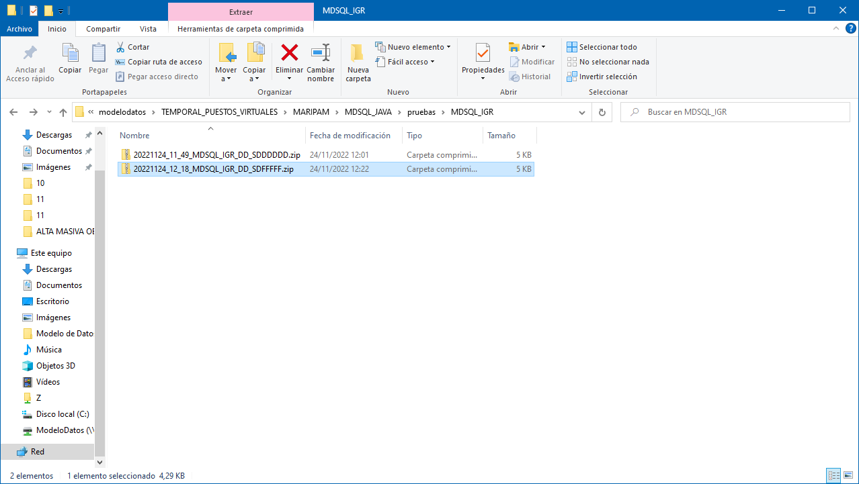

El error se ha producido al no incluir un comentario. Este campo es controlado por la lógica de negocio y cuando no está informado devuelve un error de negocio que hay que mostrar por pantalla. Si se incluye, funciona correctamente y entrega el procesado.

**V.2 (20221213) Continúa produciéndose**

1. Al rechazar un script, una vez puesto el mensaje y dado a Aceptar, sigue saliendo la ventana del motivo del rechazo.
2. Tras producirse un error en un script, si pulsamos el botón de Excepción, se muestra la pantalla para introducir el comentario de la excepción y se invoca al procedimiento P_EXCEPCION_SCRIPT pero no se está actualizando el estado del script en el listado, cuando el mismo procedimiento devuelve los nuevos estados.

